House Price Prediction Improvement and Comparison REPORT
By Tanish Salian (MITADT)
1. Objective
The objective of this task was to improve the House Price Prediction model developed in Task 1 by applying data preprocessing techniques and comparing multiple machine learning algorithms. The goal was to identify the model that provides the most accurate predictions for housing prices.

2. Dataset Description
The California Housing Dataset was used for this project. The dataset contains housing-related information such as longitude, latitude, housing median age, total rooms, total bedrooms, population, households, median income, and ocean proximity.
The target variable is:
Median House Value
The dataset consists of 20,640 records and includes both numerical and categorical features.

3. Data Preprocessing
Before training the models, several preprocessing steps were performed:
- Missing values in the total_bedrooms column were replaced using the median value.
- The categorical feature ocean_proximity was converted into numerical format using One-Hot Encoding.
- Feature Scaling was applied using StandardScaler.
- The dataset was divided into training data (80%) and testing data (20%).
These preprocessing steps improved data quality and ensured fair comparison between models.

4. Models Implemented
Linear Regression
Linear Regression was used as the baseline model for predicting house prices.
Random Forest Regressor .Random Forest Regressor was implemented as an advanced ensemble learning algorithm capable of handling complex relationships within the data.

5. Model Evaluation
The models were evaluated using the following metrics:
- Mean Absolute Error (MAE)
- Root Mean Squared Error (RMSE)
- R² Score
Results
Model | MAE | RMSE | R² Score
Linear Regression | 50,670.74 | 70,060.52 | 0.6254
Random Forest | 31,631.02 | 49,008.79 | 0.8167

Performance Analysis
The Random Forest model achieved lower MAE and RMSE values compared to Linear Regression, indicating more accurate predictions. It also obtained a significantly higher R² Score, demonstrating a better ability to explain the variation in house prices.

6. Model Comparison
A comparison of the R² Scores shows a clear improvement in performance when using Random Forest Regressor.
Insert:
- Model Comparison Graph
- Actual vs Predicted Plot
The comparison graph illustrates that Random Forest achieved an R² Score of 0.8167, outperforming Linear Regression which achieved 0.6254.

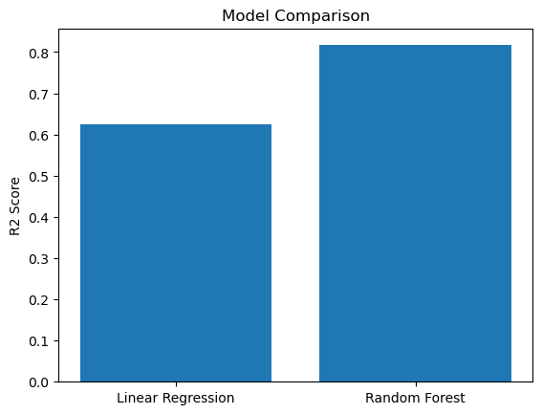

7. Best Model Selection
The Random Forest Regressor achieved the best performance among the evaluated models.
- Lowest MAE: 31,631.02
- Lowest RMSE: 49,008.79
- Highest R² Score: 0.8167
The model explains approximately 81.67% of the variance in house prices and provides significantly better prediction accuracy than Linear Regression.
Therefore, Random Forest Regressor was selected as the final model for the House Price Prediction system.

8. Conclusion
This task successfully improved the House Price Prediction system through data preprocessing, feature scaling, and model comparison.
The Random Forest Regressor significantly outperformed Linear Regression, improving the R² Score from 0.6254 to 0.8167. The results demonstrate the importance of testing multiple algorithms and selecting models based on measurable performance metrics.
This project provided practical experience with model optimization, evaluation techniques, and industry-standard machine learning workflows.

9. Future Improvements
The following techniques can further improve prediction performance:
- Feature Engineering
- Hyperparameter Tuning
- Outlier Detection and Removal
- Gradient Boosting Regressor
- XGBoost Regressor
- Cross Validation Techniques
These enhancements may improve model accuracy and robustness in future versions of the system.

